End-to-End MLOps Pipeline for Heart Disease Prediction
Course: MLOps (S1-25_AIMLCZG523)
Assignment: Experimental Learning Assignment – I
Student Name Details:
- Bishnu Maharana - 2024ab05174 - 100%
- Nagendran J - 2024aa05712 - 100%
- Pavan Kumar S - 2024aa05713 - 100%
- Hundi Rama Abhinav - 2023ac05477 – 100%
- Ghanender Singh Chauhan - 2024AA05166 -100%
GitHub Repository: https://github.com/prasadbishnu09/heart-disease-mlops
YouTube Link: https://www.youtube.com/watch?v=jsKWVt3pmpk
1. Introduction
Machine Learning systems deployed in real-world environments require more than model accuracy. They must be reproducible, scalable, monitored, and continuously validated. MLOps bridges the gap between model development and production deployment by integrating software engineering practices such as CI/CD, containerization, experiment tracking, and monitoring.
This project implements an end-to-end MLOps pipeline to predict the risk of heart disease using patient health data. The solution covers data preprocessing, model development, experiment tracking using MLflow, automated testing and CI/CD using GitHub Actions, containerized deployment using Docker, and runtime logging for monitoring.
2. Dataset Description
The dataset used is the Heart Disease UCI Dataset, obtained from the UCI Machine Learning Repository.
Dataset Characteristics:
- Format: CSV
- Number of features: 13 clinical features
- Target variable: Binary (0 – No heart disease, 1 – Presence of heart disease)
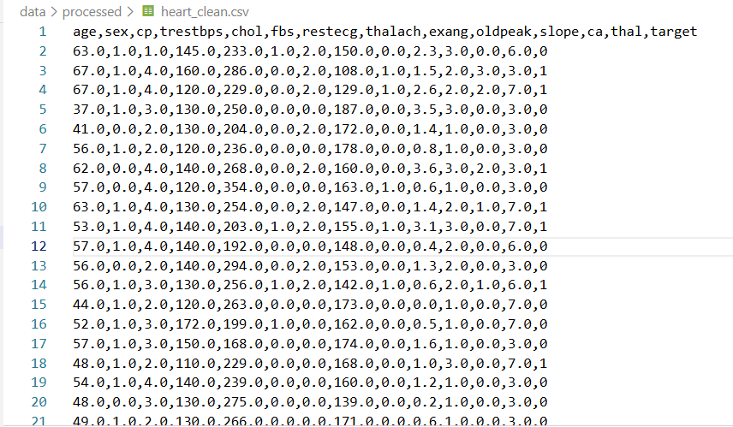
Key Features:
- Age
- Sex
- Chest pain type (cp)
- Resting blood pressure (trestbps)
- Serum cholesterol (chol)
- Fasting blood sugar (fbs)
- Resting ECG results (restecg)
- Maximum heart rate achieved (thalach)
- Exercise induced angina (exang)
- ST depression (oldpeak)
- Slope of ST segment (slope)
- Number of major vessels (ca)
- Thalassemia (thal)
3. Data Acquisition and Exploratory Data Analysis (EDA)
The dataset was downloaded from the UCI repository and stored locally. Data preprocessing steps included:
- Handling missing values
- Ensuring correct data types
- Removing inconsistencies
- Saving a cleaned dataset for reproducibility
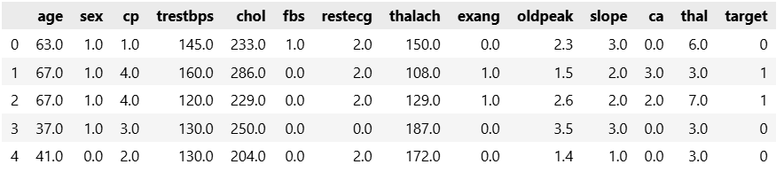
EDA Techniques Used:
- Histograms to visualize feature distributions
- Correlation heatmap to understand feature relationships
- Class distribution analysis to assess imbalance
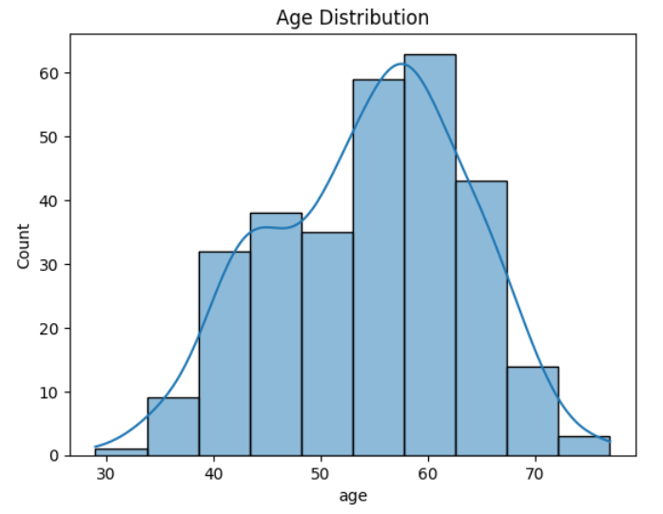 | 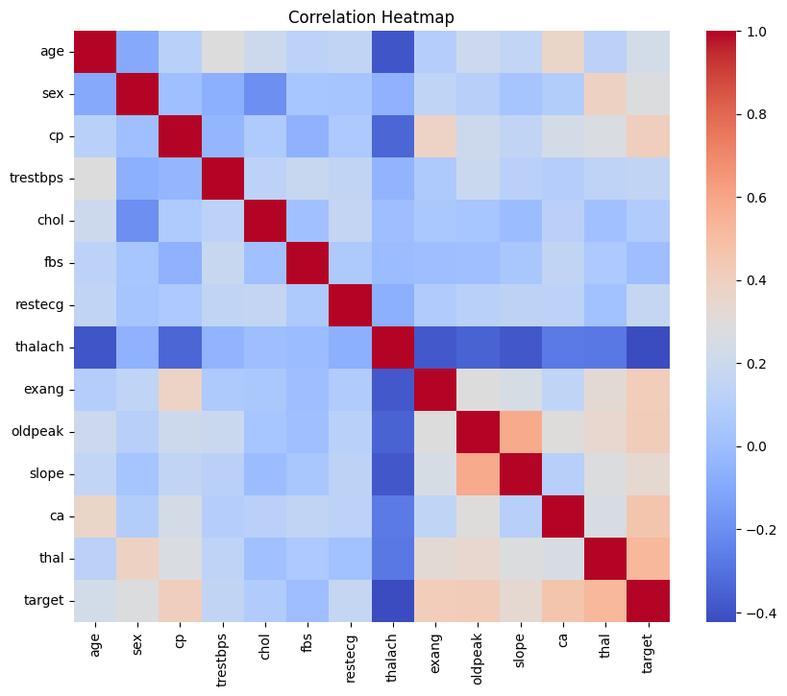 | 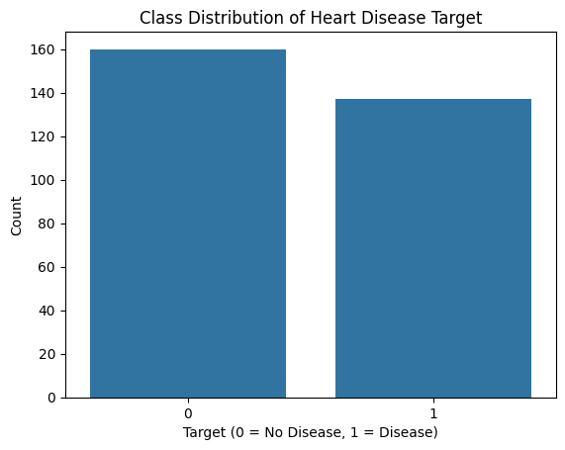

EDA helped identify important correlations such as age vs. heart disease risk and the influence of exercise-related features.
4. Feature Engineering and Model Development
Feature Engineering
- Numerical features were scaled using StandardScaler
- Feature order was preserved for reproducibility
- The preprocessing pipeline was saved alongside the model
Models Implemented
- Logistic Regression
- Random Forest Classifier
Evaluation Metrics
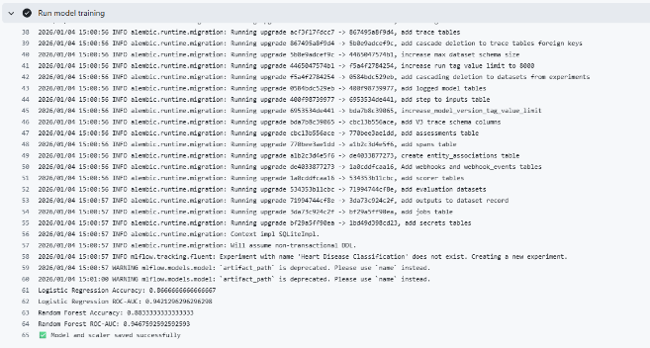
- Accuracy
- Precision
- Recall
- ROC-AUC
The Random Forest model showed slightly better ROC-AUC and accuracy and was selected as the final model.
Logistic Regression Accuracy: 0.8666666666667; Logistic Regression ROC-AUC: 0.942129629298
Random Forest Accuracy: 0.8833333333333; Logistic Regression ROC-AUC: 0.94675925925925
5. Experiment Tracking using MLflow
MLflow was integrated to track:
- Model parameters
- Evaluation metrics
- Artifacts (models and plots)
Each training run was logged as an independent experiment. The MLflow UI was used to compare Logistic Regression and Random Forest models and identify the best performing model.
Experiment tracking ensured full traceability and reproducibility of results.
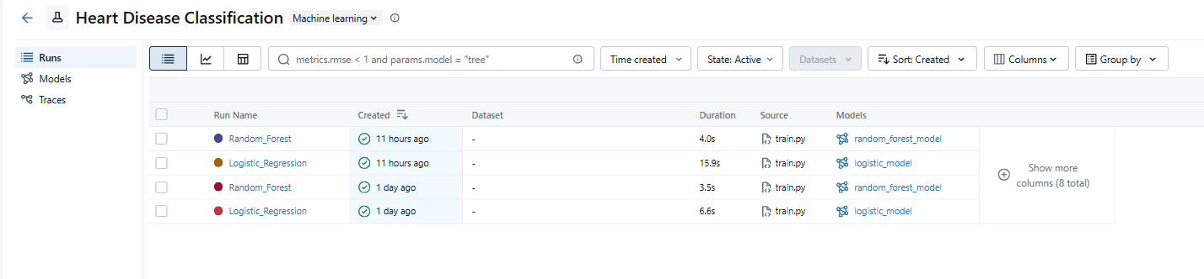
For our assignment we trained our datasets 2 times the same has been displayed here in below experiment tracking.
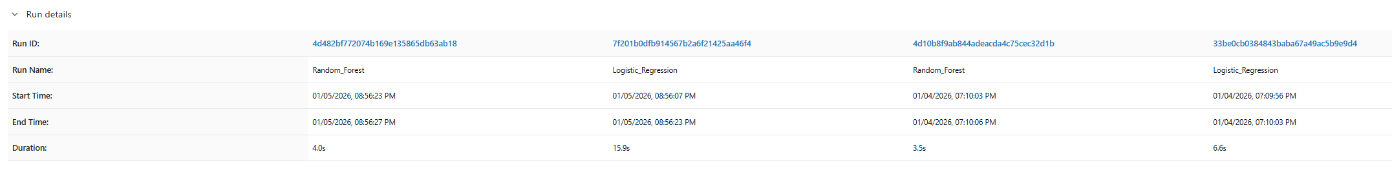
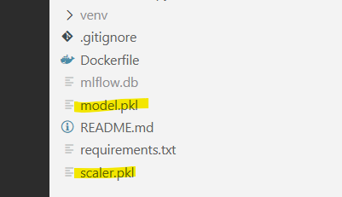
6. Model Packaging and Reproducibility
The final model and scaler were serialized using joblib:
- model.pkl
- scaler.pkl

A requirements.txt file was created to capture all dependencies. This enables the project to be reproduced from a clean environment without manual intervention.
7. CI/CD Pipeline and Automated Testing
Unit Testing
- Pytest was used for testing data preprocessing and model inference
- Tests validated data shape, model predictions, and pipeline consistency
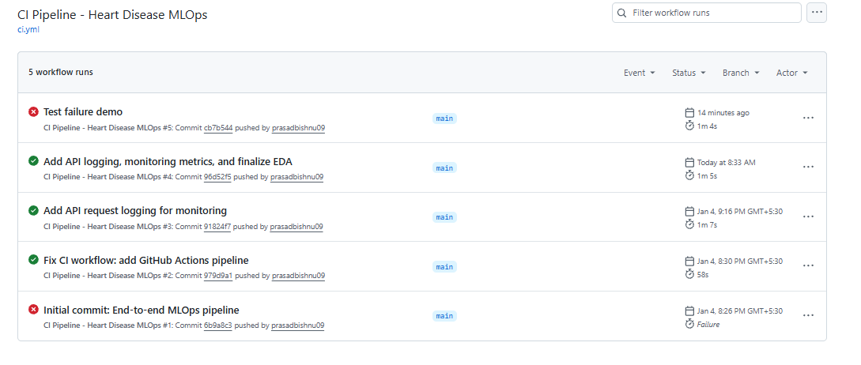
CI/CD Pipeline
GitHub Actions was configured to automatically:
- Install dependencies
- Run unit tests
- Fail the pipeline if errors occur
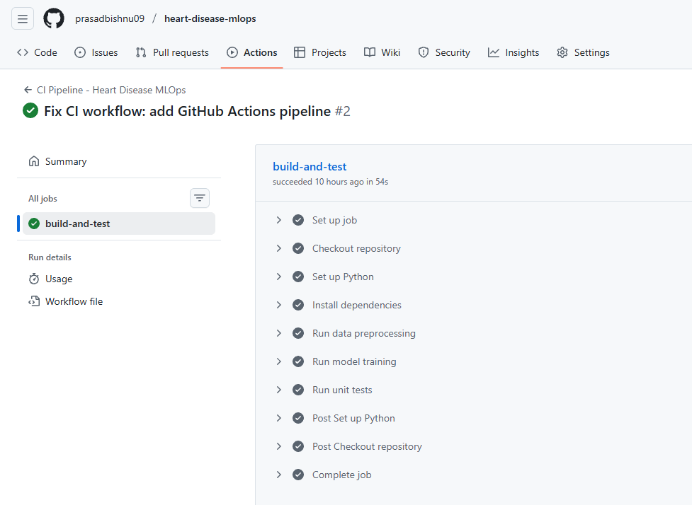

The CI pipeline ensures that every code change is validated before integration.

Pipeline failed on code errors and gave clear logs.
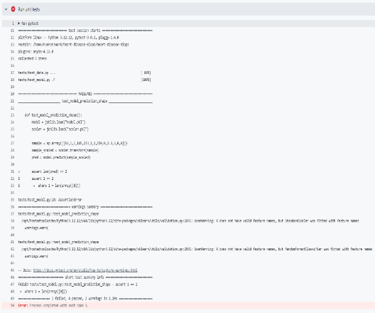
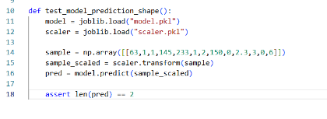

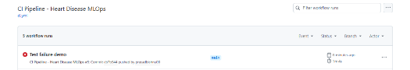

8. Model Containerization
The FastAPI application was containerized using Docker.
Key Highlights:
- Base image: Python 3.12 slim
- Exposed port: 8000
- API endpoint: http://127.0.0.1:8000/docs#/default/predict_predict_post
The Docker container ensures portability and isolation from the host system.
API Testing of 2 below positive Testcases:
Testcase1:
- Input format-1: {"age":63,"sex":1,"cp":1,"trestbps":145,"chol":233,"fbs":1,"restecg":2,"thalach":150,"exang":0,"oldpeak":2.3,"slope":3,"ca":0,"thal":6}
- Output: {"prediction":0,"confidence":0.30}
- O/P of Input 1:
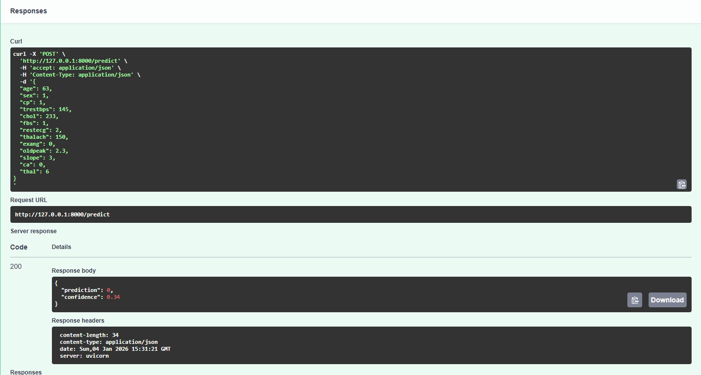
Prediction = 0 means Model predicts NO heart disease
Confidence = 0.34 means Probability of having heart disease = 34%
Testcase2:
- Input format-2: {"age":68,"sex":1,"cp":3,"trestbps":180,"chol":320,"fbs":1,"restecg":2,"thalach":95,"exang":1,"oldpeak":4.2,"slope":1,"ca":3,"thal":7}
- Output: {"prediction":1,"confidence":0.52}
O/P of Input 2:
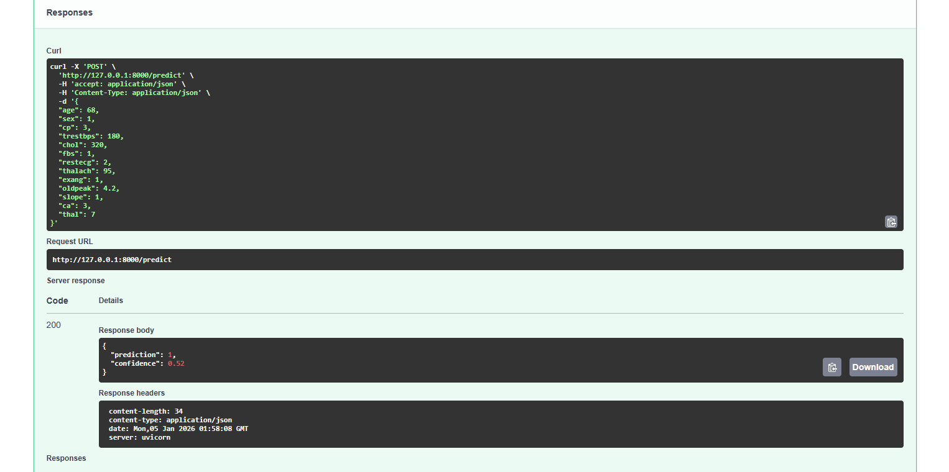
Prediction = 1 means Model predicts having heart disease
Confidence = 0.52 means Probability of having heart disease = 52%

9. Production Deployment
The Dockerized API was deployed using Docker Desktop as a local production-like environment.
Deployment Steps:
docker build -t heart-disease-api .
docker run -p 8000:8000 heart-disease-api
The API was verified using:
- Browser access (/)
- Swagger UI (/docs)
- Prediction endpoint (/predict)
- Promethius Metrices
Docker Desktop provides a controlled, production-ready execution environment suitable for academic and enterprise use cases.
URLs
API running --> http://127.0.0.1:8000/
Swagger --> http://127.0.0.1:8000/docs

10. Monitoring and Logging
Application-level logging was integrated using Python’s logging module.
Logged information includes:
- Request timestamps
- Input payloads
- Model predictions
- Confidence scores
Logs were observed during runtime in the Docker container, providing basic monitoring and traceability of predictions.
Prometheus metrics --> http://127.0.0.1:8000/metrics
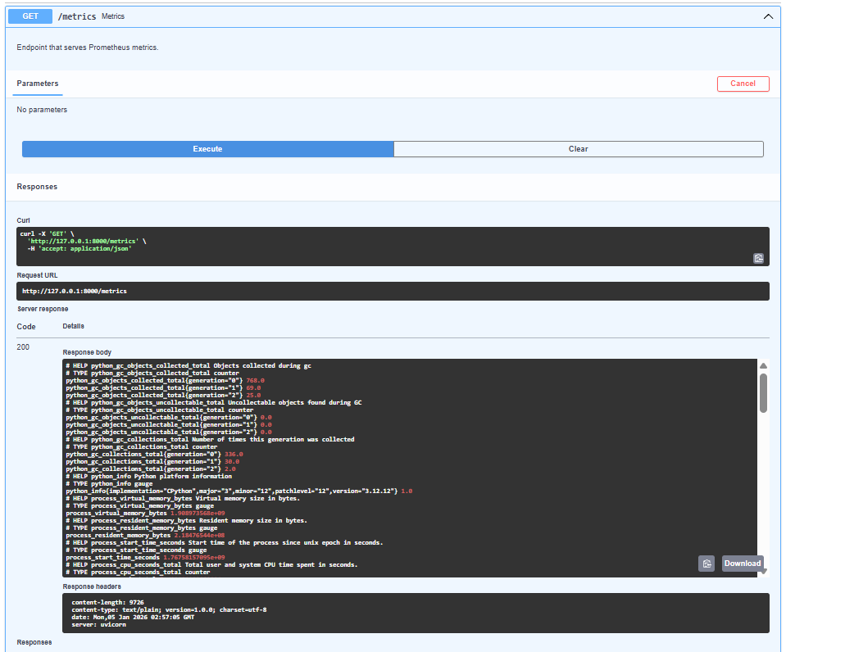

11. Architecture Diagram
High-Level Architecture:
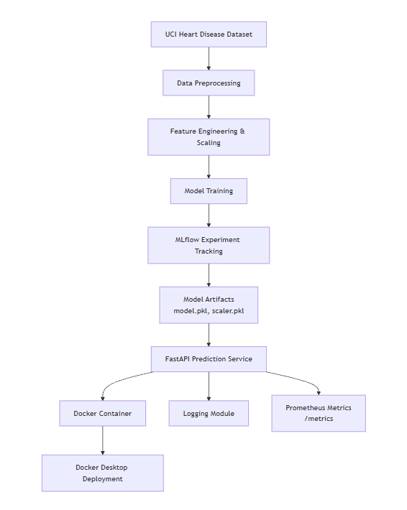
12. Conclusion
This project successfully demonstrated an end-to-end MLOps workflow for building, deploying, and monitoring a machine learning model to predict heart disease risk using the UCI Heart Disease dataset. The solution followed industry-standard practices, beginning with data preprocessing, exploratory data analysis, and feature engineering, followed by training and evaluation of multiple models including Logistic Regression and Random Forest. MLflow was integrated to track experiments, compare model performance, and ensure reproducibility by logging parameters, metrics, and model artifacts. Automated testing and a CI pipeline using GitHub Actions further strengthened the reliability and maintainability of the system.
The trained model was deployed as a production-ready FastAPI service, containerized using Docker, and executed in an isolated environment to ensure consistent behavior across systems. Application-level logging and basic monitoring using Prometheus metrics provided visibility into request handling, predictions, and system health, fulfilling key production-readiness requirements. Overall, this project highlights how MLOps practices bridge the gap between experimentation and real-world deployment, enabling scalable, reproducible, and observable machine learning systems suitable for enterprise use.

